|  |  |  |  |  |  |
| --- | --- | --- | --- | --- | --- |
| Date | 6-Sep-22 | | | Tester Name | Mohammad Yusuf |
| Environment | Penfax - Test | | | Login used |  |
| Operating System | Select OS | Version: | Update: | | |
| Software Used | Select Software | Version: | Update: | | |
| Select Software | Version: | Update: | | |
| Release version |  | | | | |
| Title | M17 Contributions & DCT | | | | |
| Test Type | Regression | | | | |
| Test Scenario | M17.09 Creating a Return to Work File | | | | |
|  |  | | | | |
| Expected Results | End Date for open Leave should be updated under Employee Profile. | | | | |
| Pass/Fail | Pass | | | JIRA# | N/A |

Describe your steps with screenshots:

1. Bring up a MEPP member who is on LOA and returning to work.

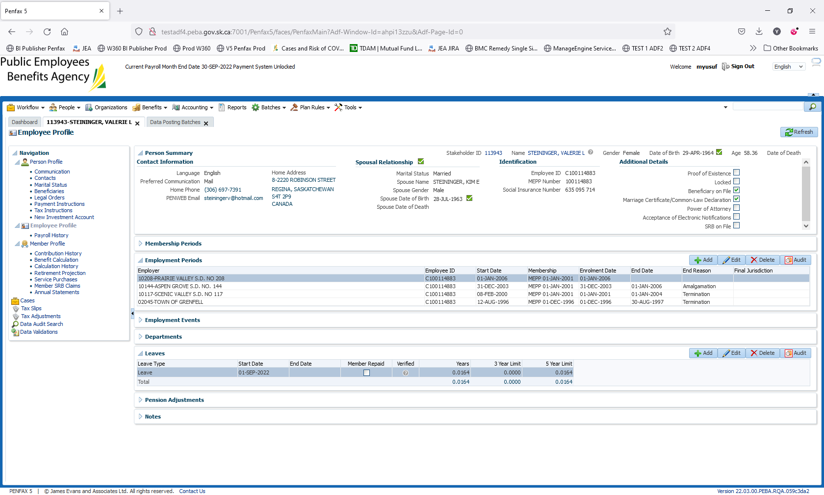

1. Log into MEPP DCT and select the Employer from the dropdown. Click on Create New File.

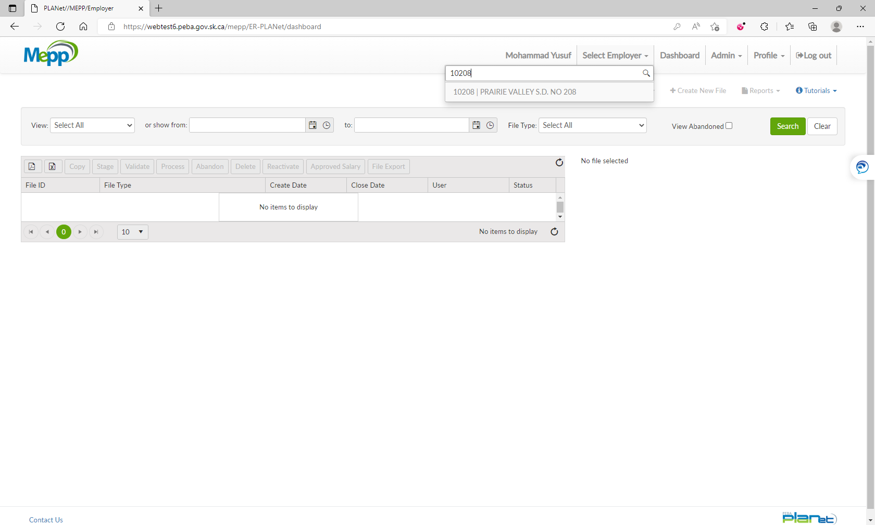

1. Select Return to Work from the dropdown and click Create.

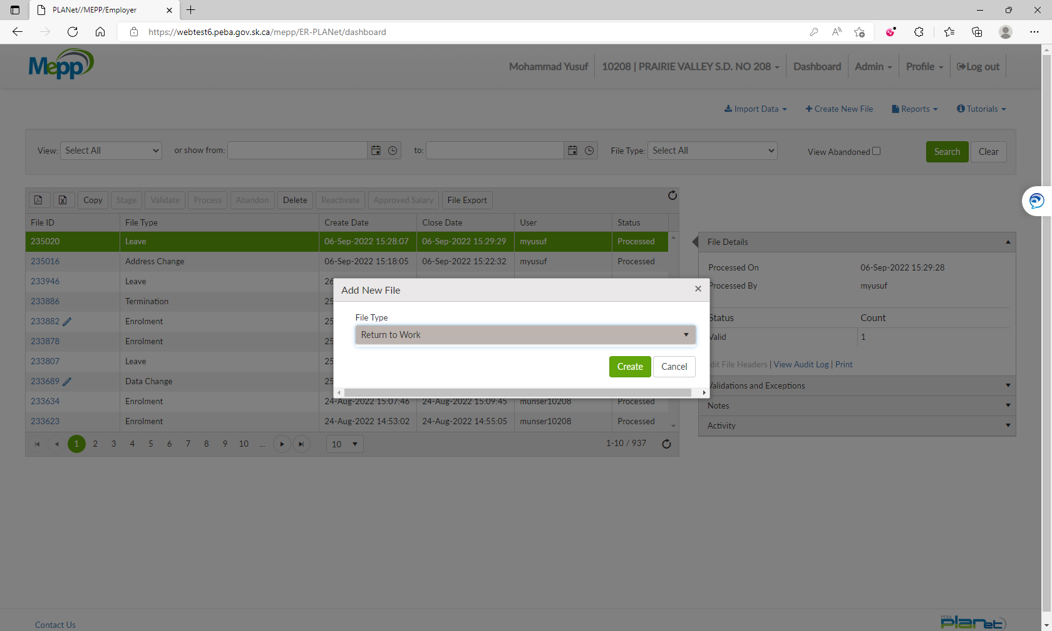

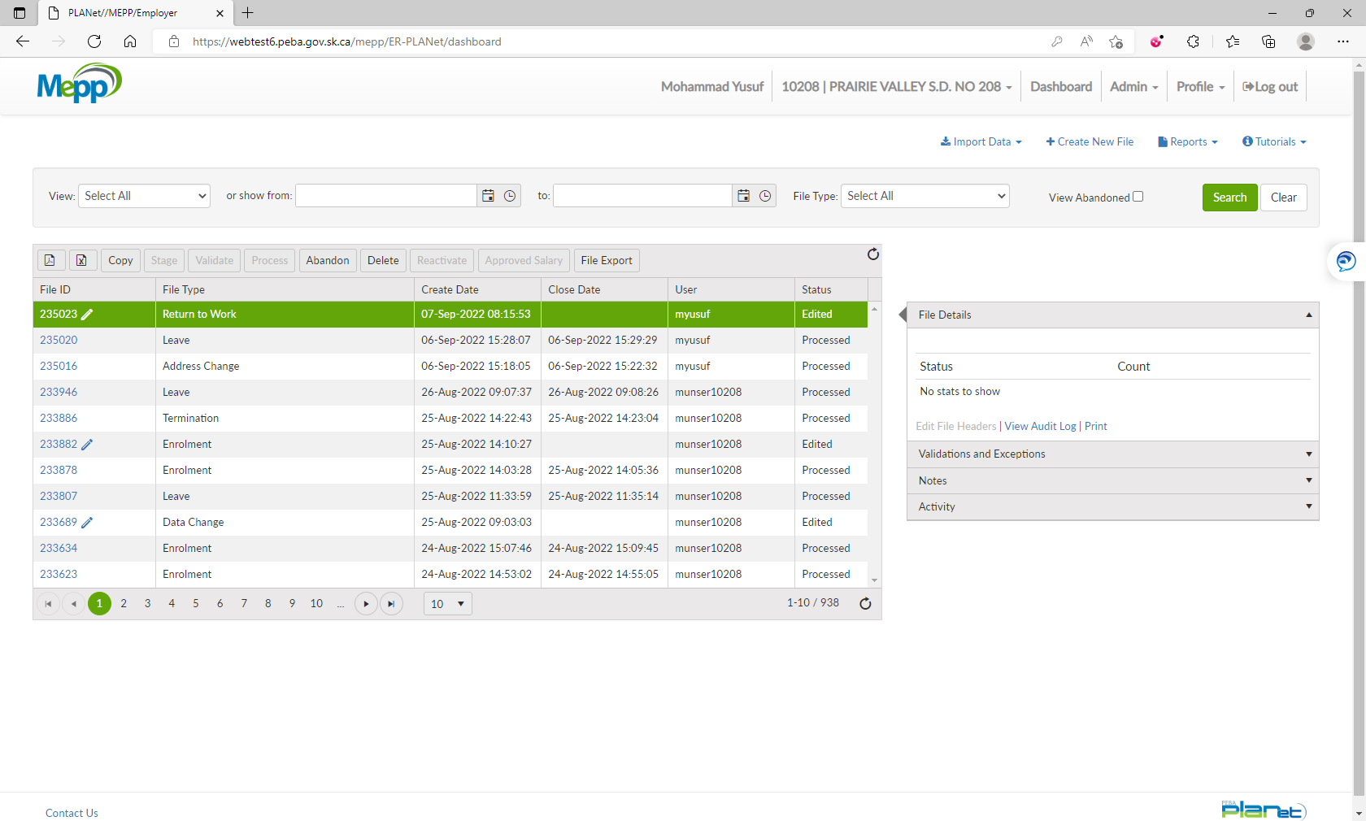

1. Click on File ID to add the transactions.

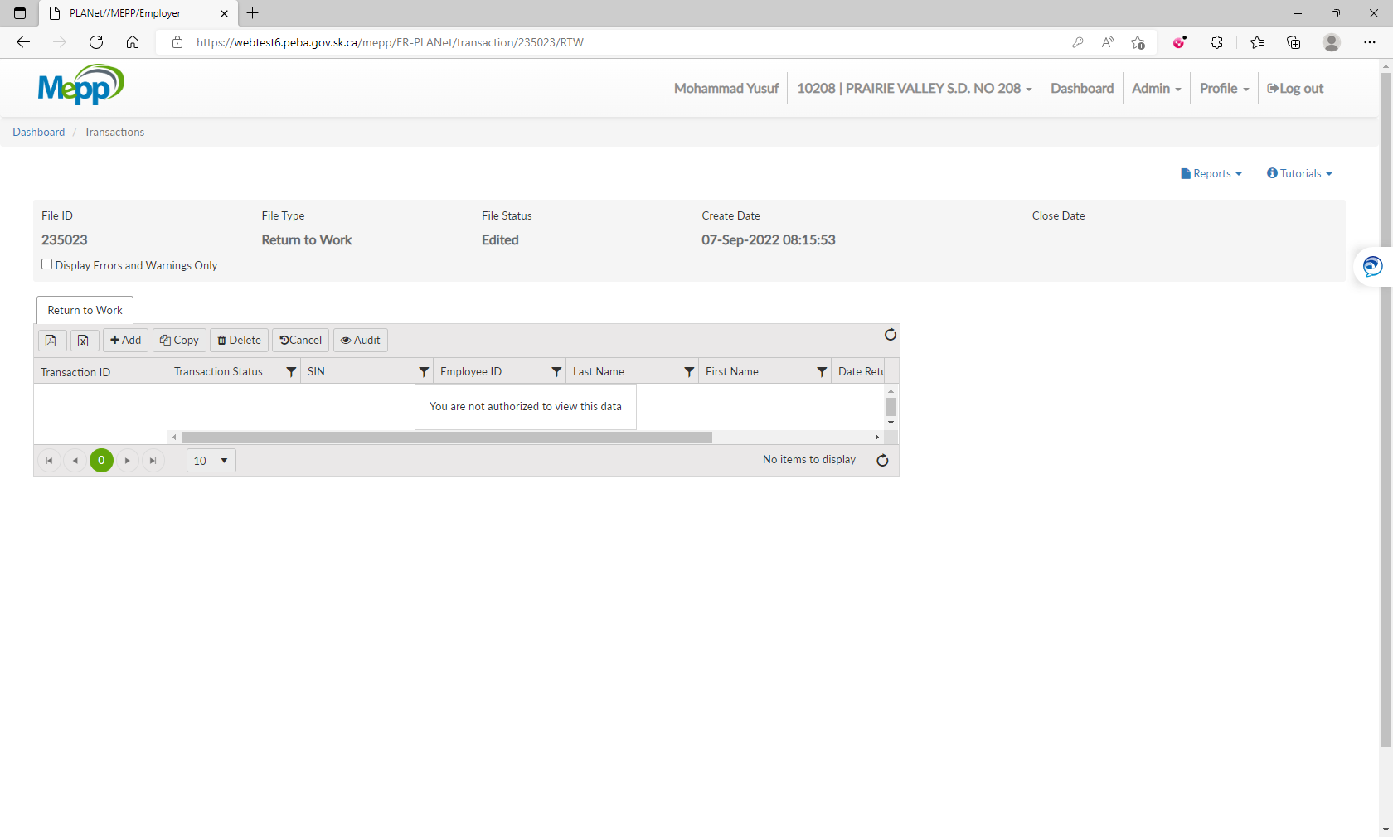

1. Input required details and click Save.

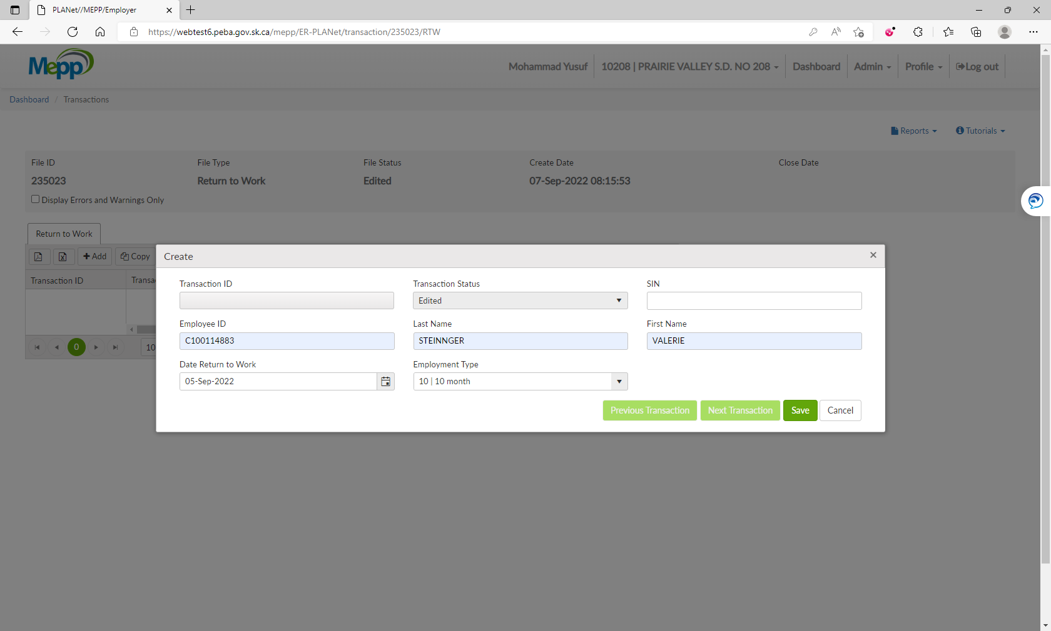

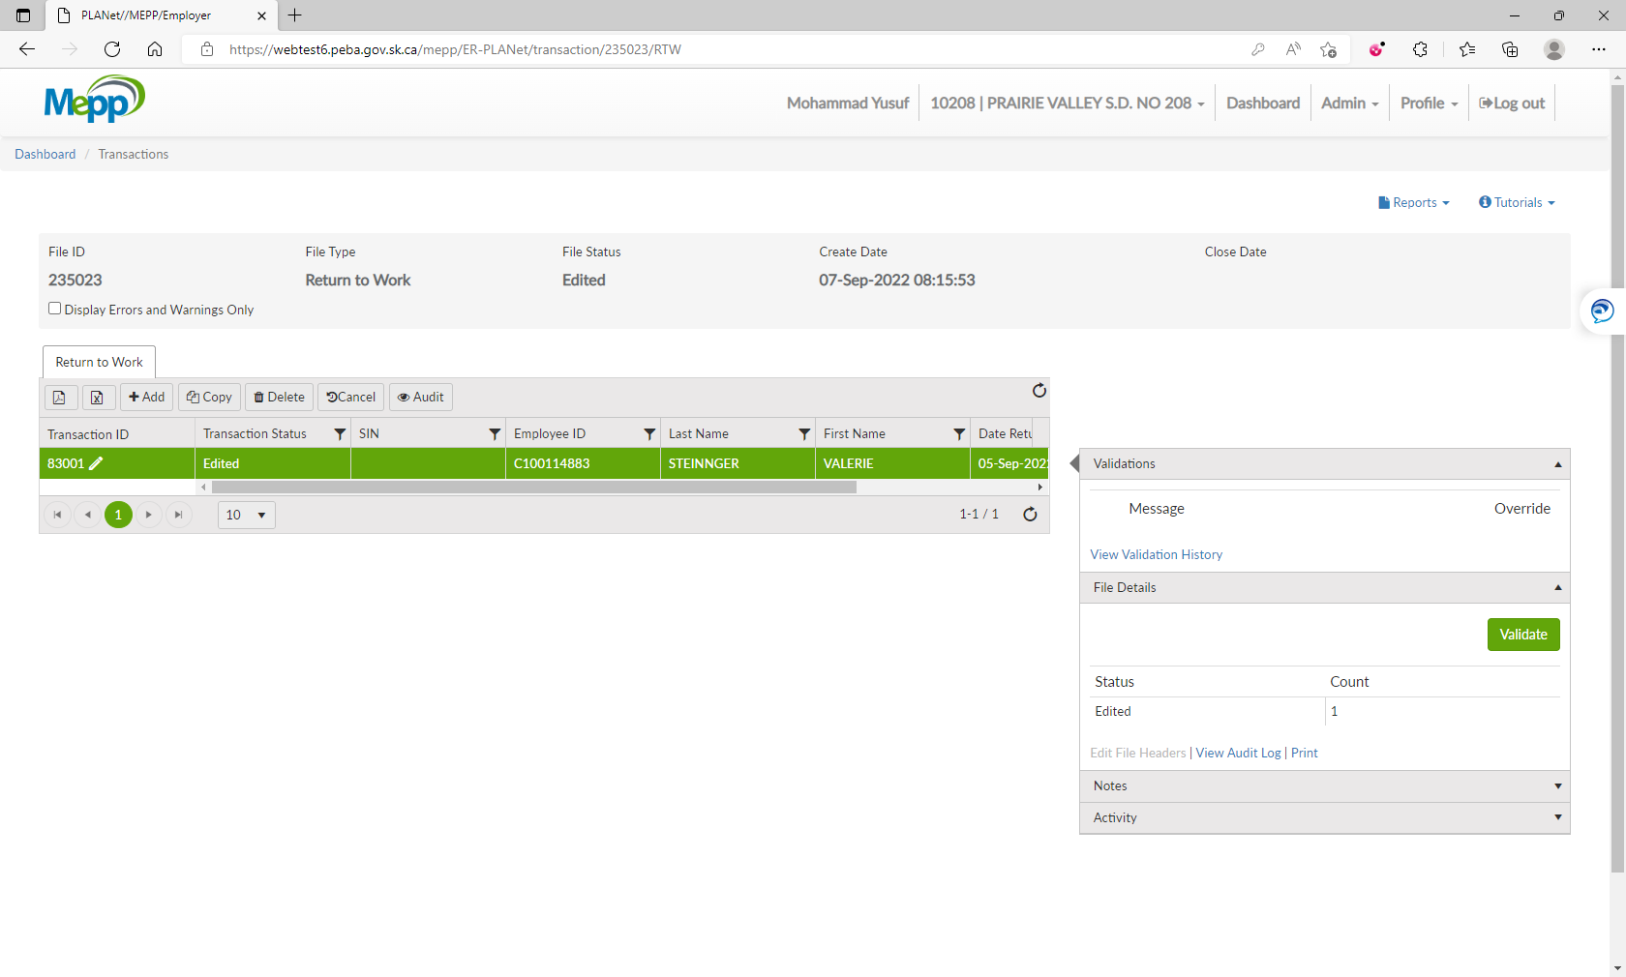

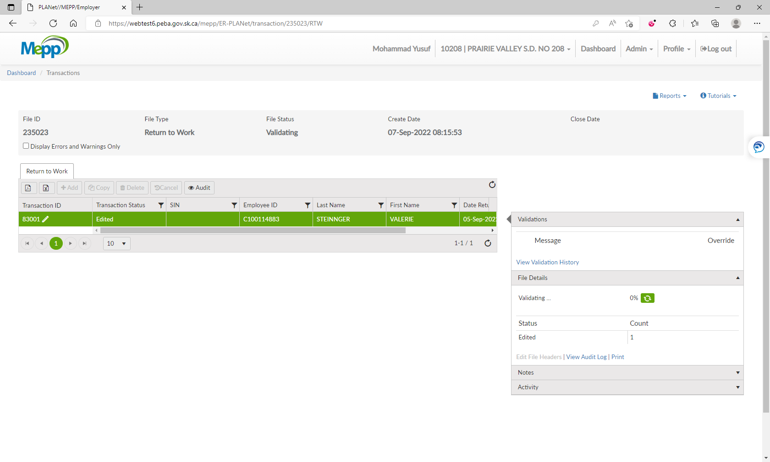

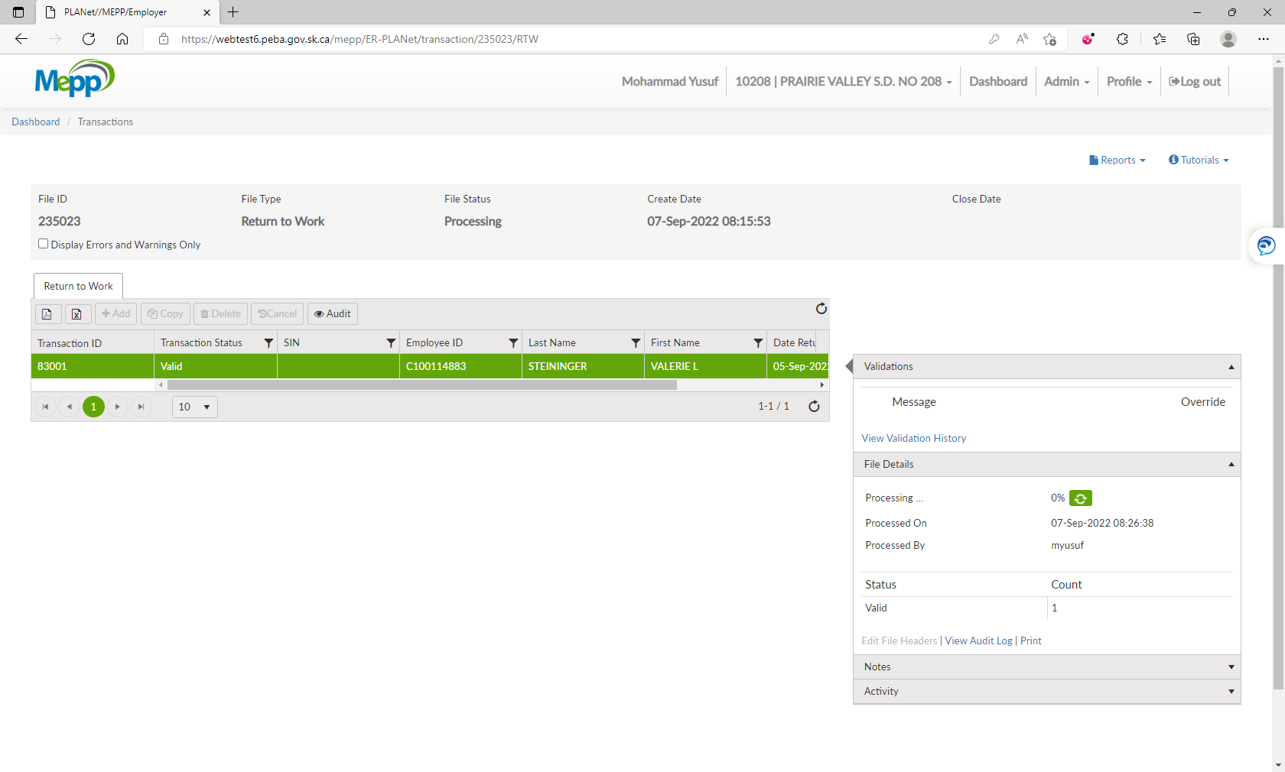

1. Under File Details, click on Validate and then Process.

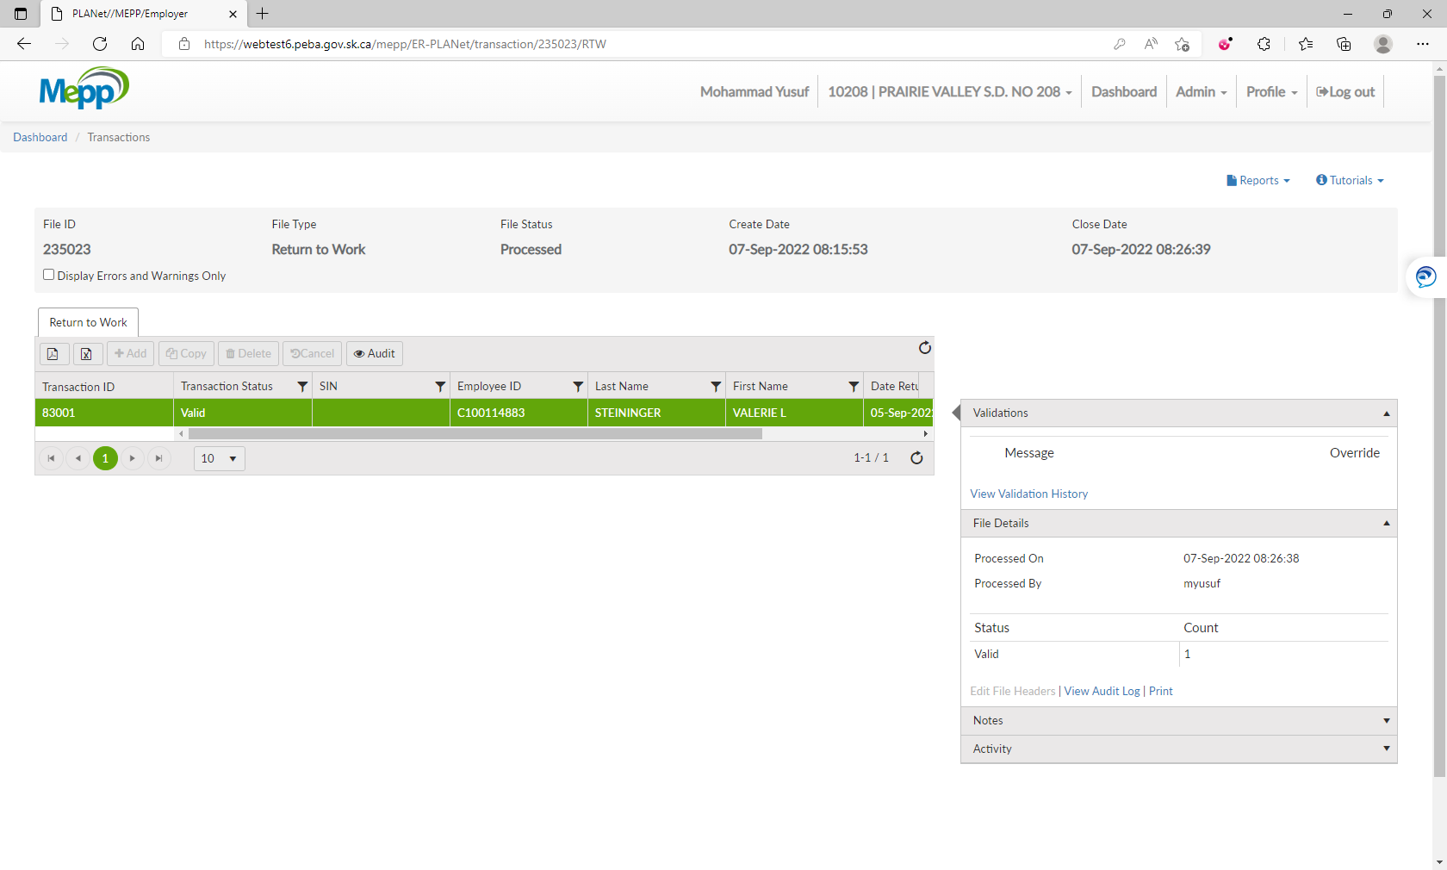

1. Go to Penfax -> Data Posting Batch -> Search by Batch Type and Employer.

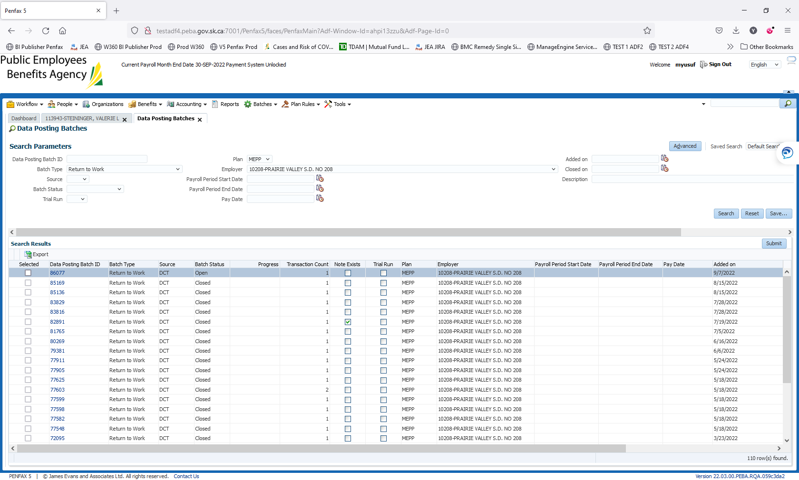

1. Open a batch you just processed through DCT. Go to Pending tab.

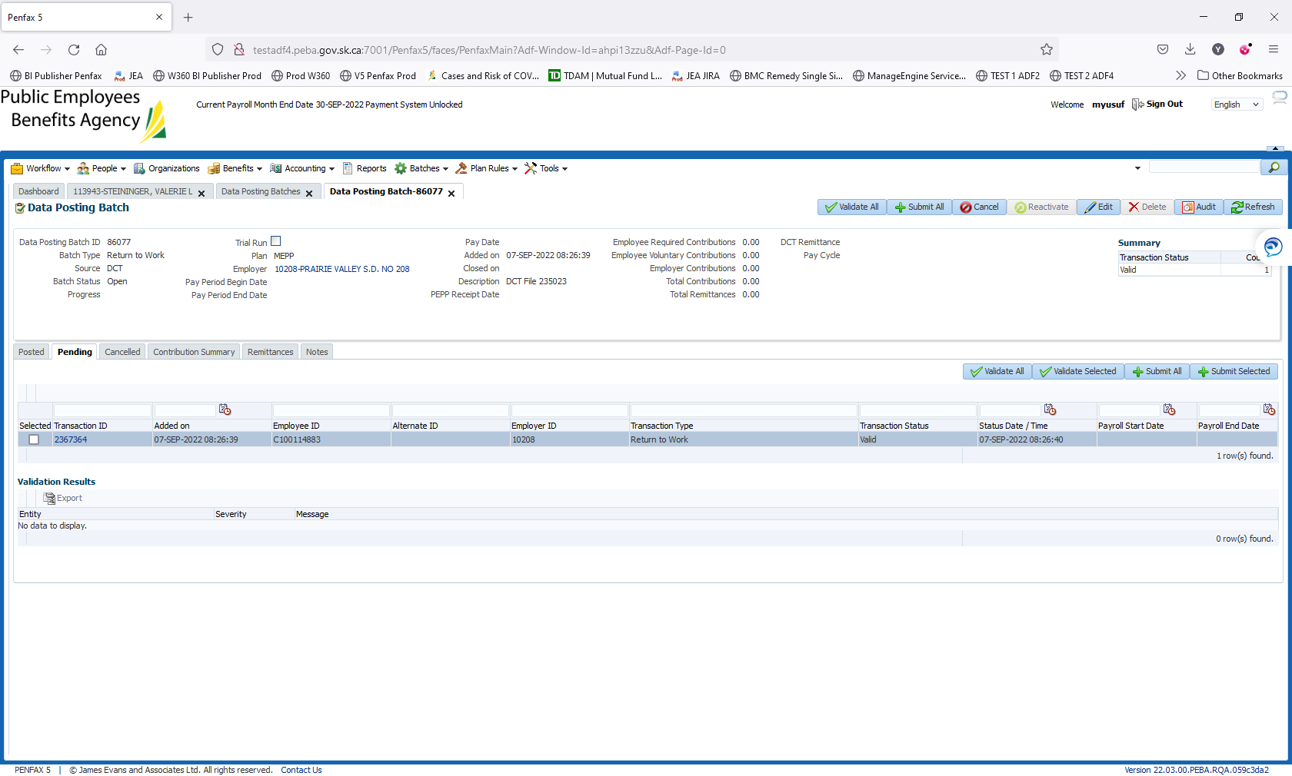

1. Click on Validate All and then Submit All.

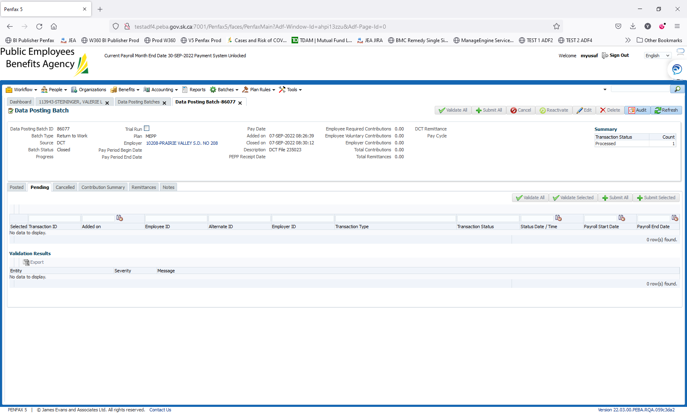

1. Batch is submitted/processed. Transaction is moved to Posted tab. Batch Status is now Closed.

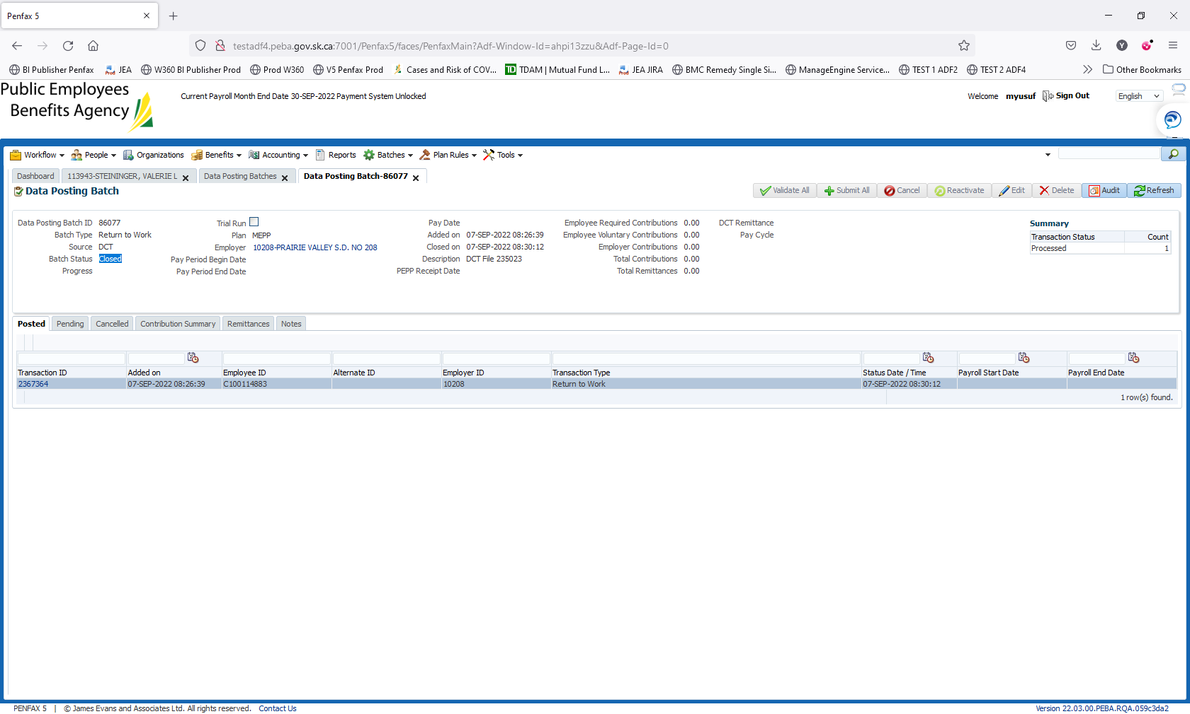

1. Bring up a stakeholder and verify that the leave has been ended under Employee Profile -> Leaves.

